**EXPERIMENT-3**

**PROCESS MANAGEMENT AND NETWORK MANAGEMENT**

* **$ps:** Shows all active user as well as system processes

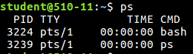

* **$ps -a:** Shows all active user processes only.



* **$ps -e:**

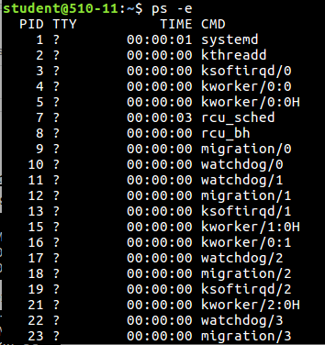

* **$ps -l:**The "-l" option will display the threads along with the processes. It can be used to display all threads of a particular process or all processes.

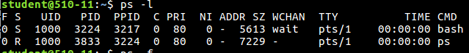

* **$ps -f:**Shows All listing Processes

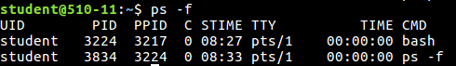

* **$pstree:***pstree* is a small, [*command line*](http://www.linfo.org/command_line.html) (i.e., all-text mode) [program](http://www.linfo.org/program.html) that displays the [*processes*](http://www.linfo.org/process.html) (i.e., executing instances of programs) on the system in the form of a *tree diagram*

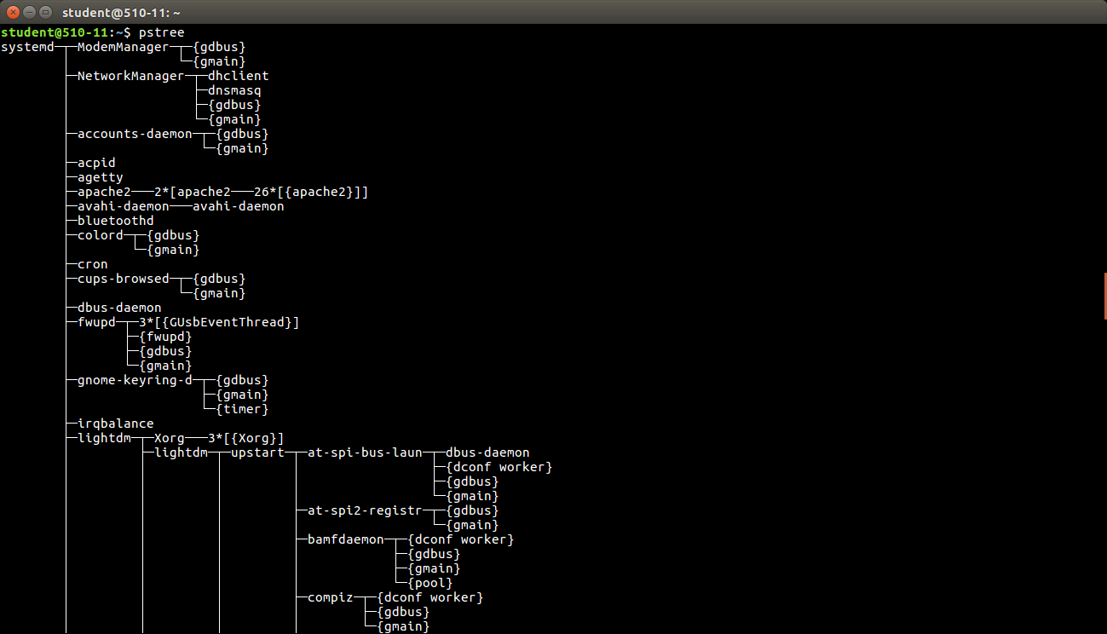

* **$top:** Top is a very useful system monitor that is really easy to use, and that can also allows us to understand why our OS suffers and which process use most resources.

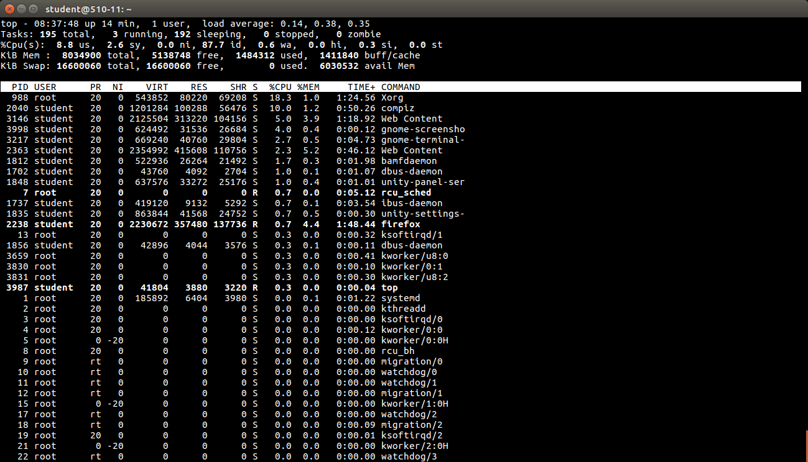

* **$jobs:**process running at background with status suspended.

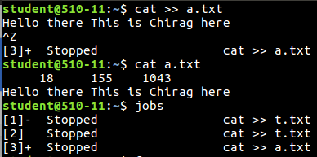

* **$fg <job ID>:**brings job in foreground.

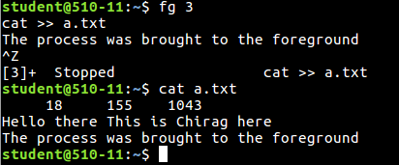

* **$sort <file name> &:** Starts the process in the background again.

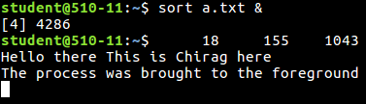

* **$bg <process ID>:** brings job in background

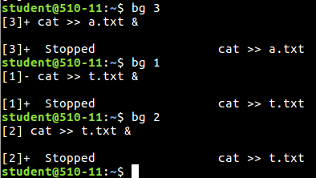

* **$jobs -p <job ID>:** Displays the process ID of job with the the given job ID

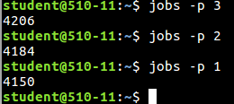

* **$jobs -l:**does long listing of the jobs

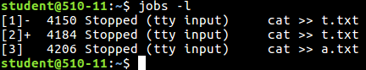

* **$jobs:**process running at background with status suspended.

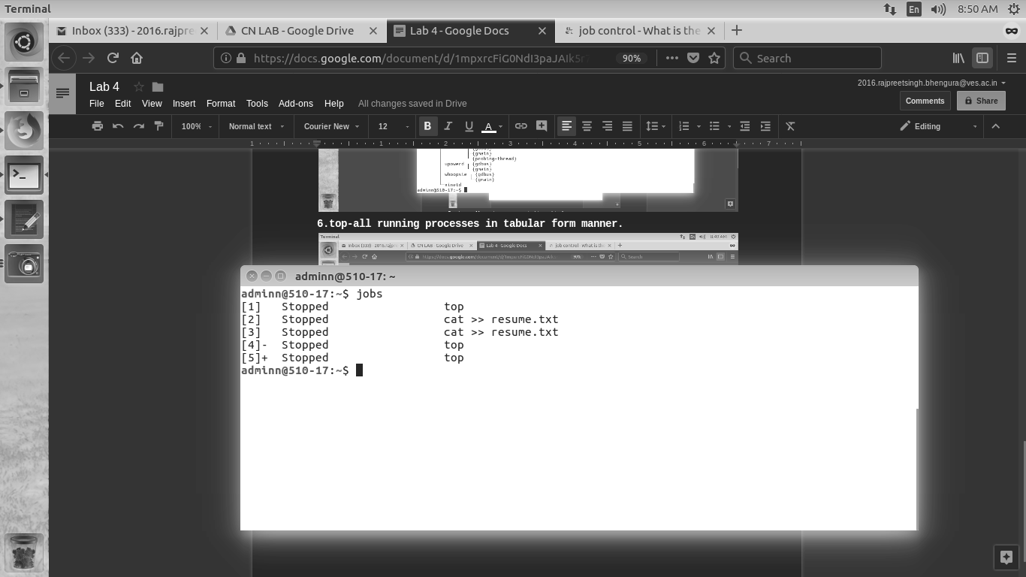

* **$kill <process ID>:** Tries to terminate/kill the process with the given process ID.

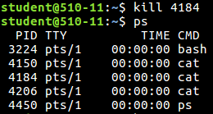

* **$kill -9 <process ID>:** Forcefully kills the program with the given process ID.

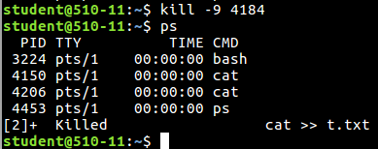

**NETWORKING COMMANDS**

* **$ifconfig:**You can use the **ifconfig** command to assign an address to a network interface and to configure or display the current network interface configuration information.After system startup, it can also be used to redefine an interfaces address and its other operating parameters

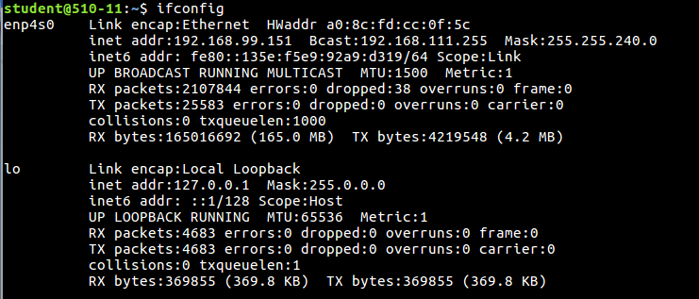

* **$nslookup <domain name>:**

nslookup is a useful tool for troubleshooting DNS problems, such as host name resolution. When you start Nslookup,it is used to obtain IP address of the domain name. 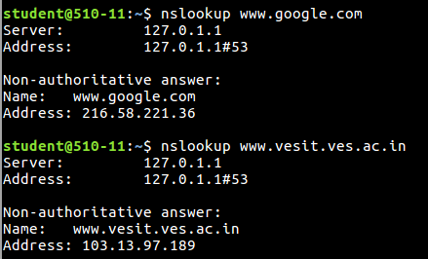

* **$netstat:**Netstat is a common command line TCP/IP networking utility available in most versions of Windows, Linux, UNIX and other operating systems. Netstat provides information and statistics about protocols in use and current TCP/IP network connections.

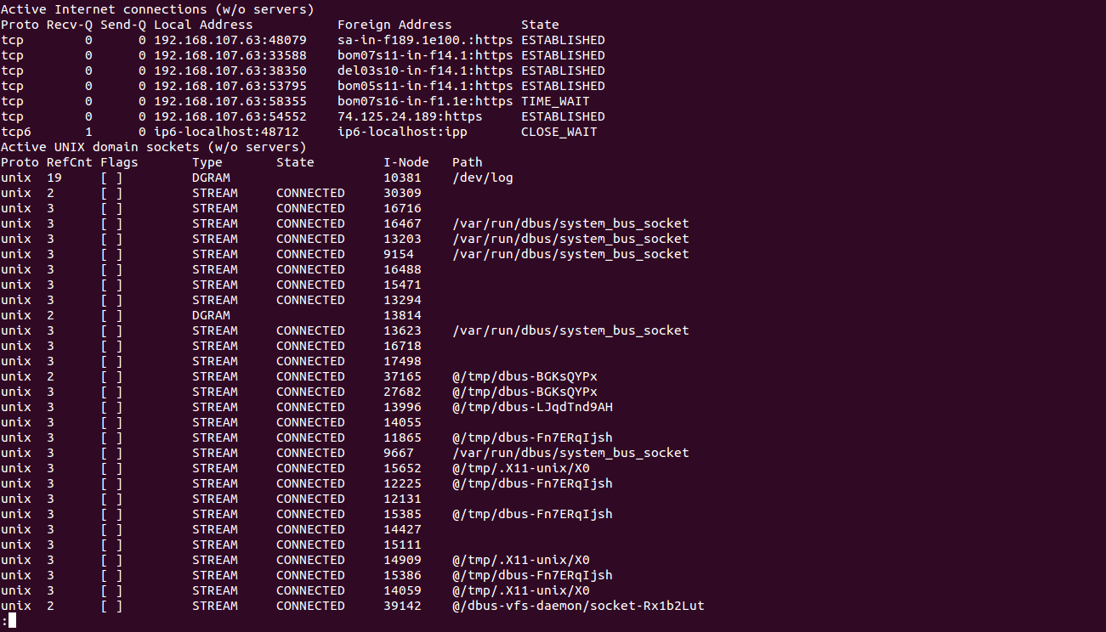

* **$ping:**The ping command is a Command Prompt command used to test the ability of the source computer to reach a specified destination computer. ... The ping command operates by sending Internet Control Message Protocol (ICMP) Echo Request messages to the destination computer and waiting for a response.The ping command returns the IP address, the size and the time taken to transfer the packets.

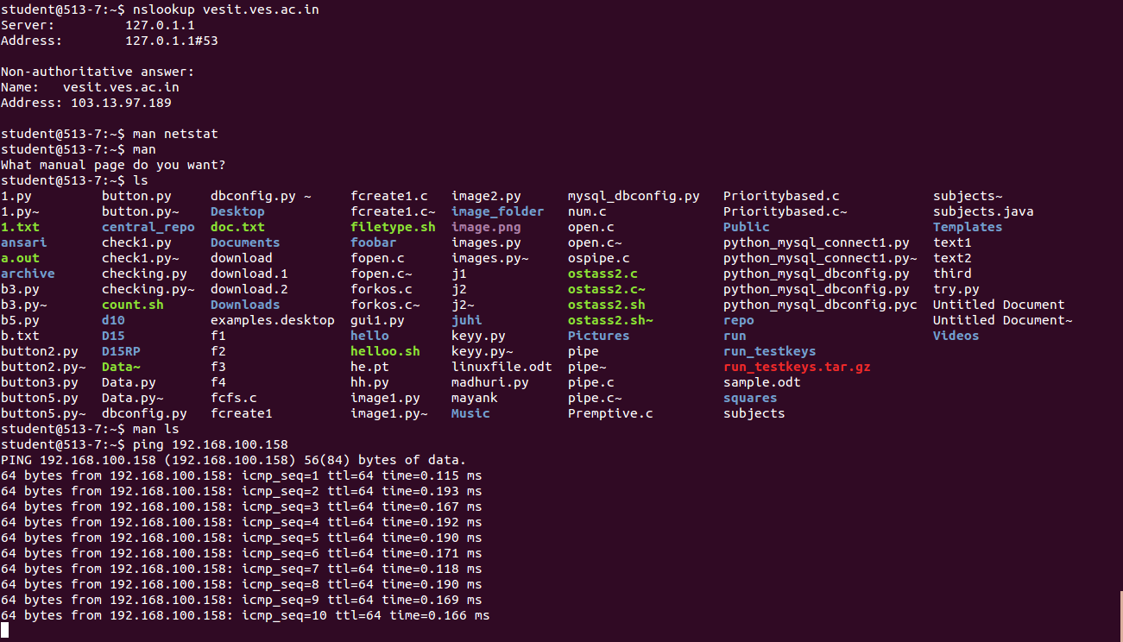

* **$traceroute:**The traceroute command is a Command Prompt command that's used to show several details about the path that a packet takes from the computer or device you're on to whatever destination you specify. You might also sometimes see the traceroute command referred to as the tracert.

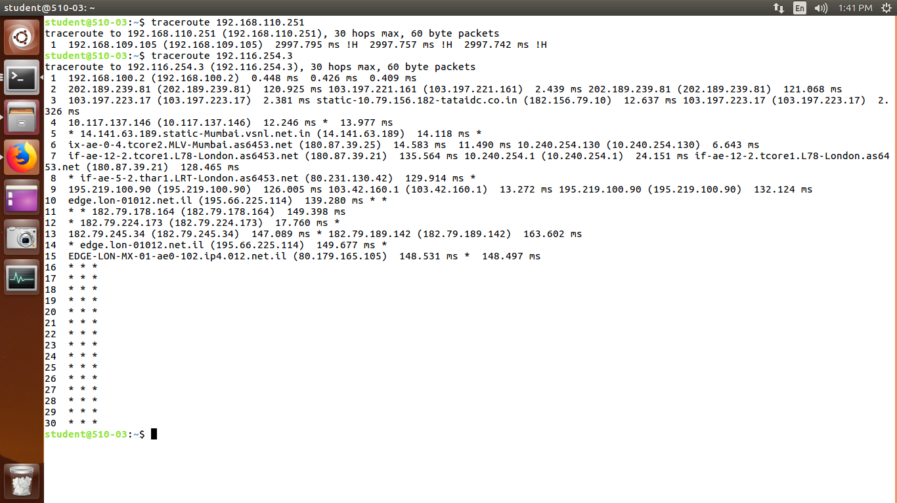

* **$arp:** Address Resolution protocol Address Resolution Protocol:-Matches Ip address to MAC address of all connections.Arp with no mode specifier will print the current content of the table. It is possible to limit the number of entries printed, by specifying an hardware address type, interface name or host address.

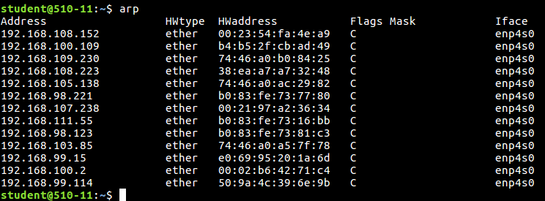

* **$rarp**:Reverse of arp



* **$ftp:**
  + **$ftp <ip address of remote machine>:**
  + **ftp> put <file name>:** puts the file of given filename on the connected pc.
  + **ftp> get <file name>:** gets the file of given filename from the connected pc.

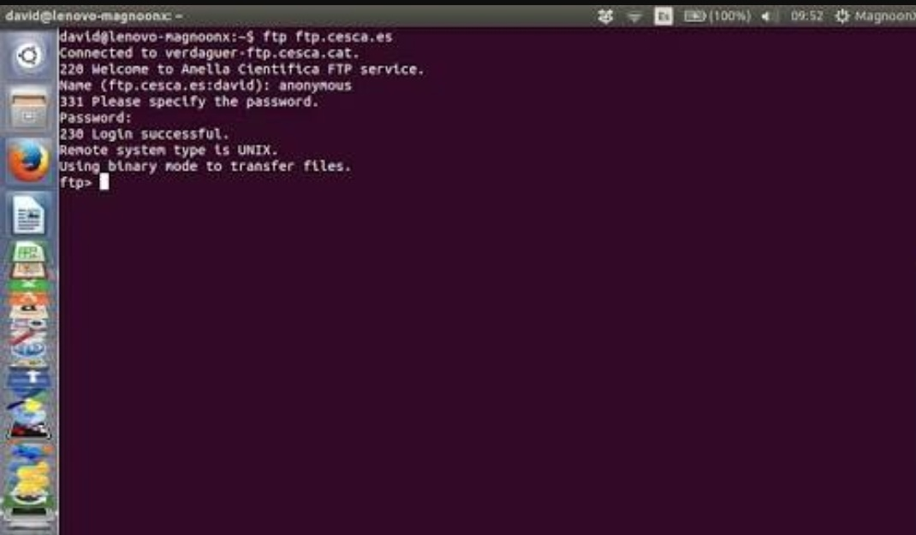

* **$telnet:**
  + Connect to a remote Linux computer  
    run programs remotely and conduct administration  
    This utility is similar to the Remote Desktop feature found in Windows Machine.  
    For demonstration purpose, we will connect to your computer (localhost). The utility will ask your username and password, if you are connected to a remote host, the commands will be executed on the remote machine, and not your local machine.  
    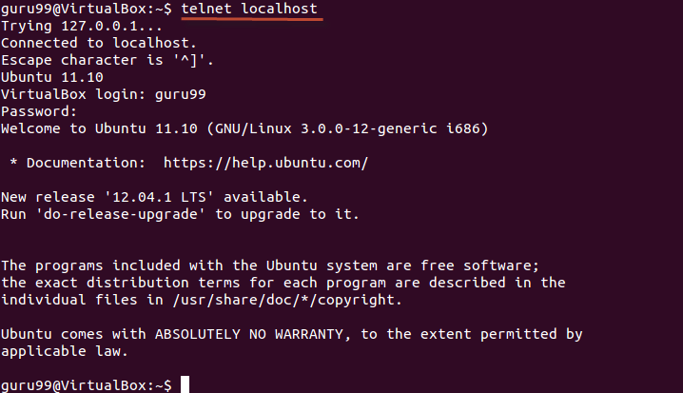

Conclusion : We have successfully implemented all linux networking and process management commands.